Kettle 动态集群的配置

启动动态集群主节点：

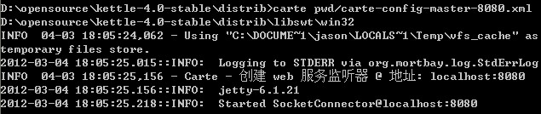

启动动态集群子节点：

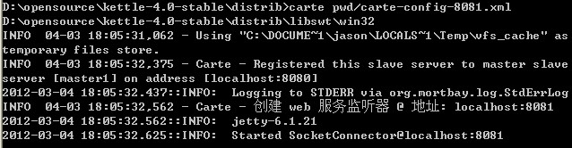

获得当前主节点上所有子节点的 url  [http://localhost:8080/kettle/getSlaves/](http://localhost:8080/kettle/getSlaves/" \t "_blank)

返回结果：

<?xml version="1.0" encoding="UTF-8" ?>

**[-](http://localhost:8080/kettle/getSlaves/)** <SlaveServerDetections>

**[-](http://localhost:8080/kettle/getSlaves/)** <SlaveServerDetection>

**[-](http://localhost:8080/kettle/getSlaves/)** <slaveserver>

<name>**Dynamic slave [localhost:8081]**</name>

<hostname>**localhost**</hostname>

<port>**8081**</port>

<webAppName />

<username>**cluster**</username>

<password>**Encrypted 2be98afc86aa7f2e4cb1aa265cd86aac8**</password>

<proxy\_hostname />

<proxy\_port />

<non\_proxy\_hosts />

<master>**N**</master>

</slaveserver>

<active>**Y**</active>

<last\_active\_date>**2012/03/04 18:07:25.250**</last\_active\_date>

<last\_inactive\_date />

</SlaveServerDetection>

</SlaveServerDetections>